**Principal Component Analysis(PCA) Implementation**

**Principal Component Analysis (PCA)**is a statistical procedure that uses an orthogonal transformation that converts a set of correlated variables to a set of uncorrelated variables. PCA is the most widely used tool in exploratory data analysis and in machine learning for predictive models. Moreover, PCA is an unsupervised statistical technique used to examine the interrelations among a set of variables. It is also known as a general factor analysis where regression determines a line of best fit.

Python3

**import** **pandas** **as** **pd**

**import** **numpy** **as** **np**

**import** **matplotlib.pyplot** **as** **plt**

**import** **seaborn** **as** **sns**

%matplotlib inline

Python3

*# Here we are using inbuilt dataset of scikit learn*

**from** **sklearn.datasets** **import** load_breast_cancer

*# instantiating*

cancer = load_breast_cancer()

*# creating dataframe*

df = pd.DataFrame(cancer['data'], columns = cancer['feature_names'])

*# checking head of dataframe*

df.head()

**Output:**

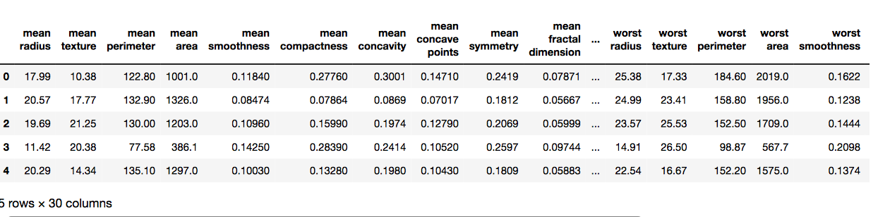

**Code #2:**

Python3

*# Importing standardscalar module*

**from** **sklearn.preprocessing** **import** StandardScaler

scalar = StandardScaler()

*# fitting*

scalar.fit(df)

scaled_data = scalar.transform(df)

*# Importing PCA*

**from** **sklearn.decomposition** **import** PCA

*# Let's say, components = 2*

pca = PCA(n_components = 2)

pca.fit(scaled_data)

x_pca = pca.transform(scaled_data)

x_pca.shape

Python3

*# giving a larger plot*

plt.figure(figsize =(8, 6))

plt.scatter(x_pca[:, 0], x_pca[:, 1], c = cancer['target'], cmap ='plasma')

*# labeling x and y axes*

plt.xlabel('First Principal Component')

plt.ylabel('Second Principal Component')

**Output:**

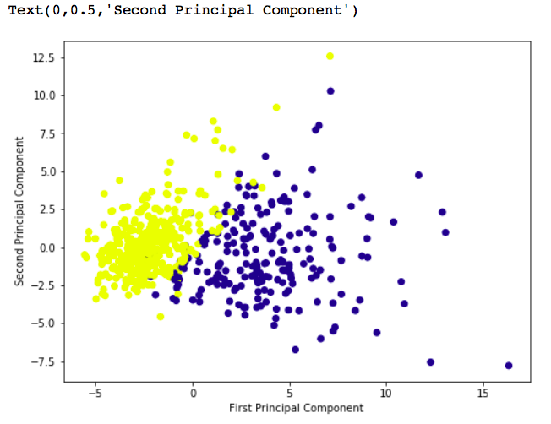

Python3

pca.components_

**Output:**

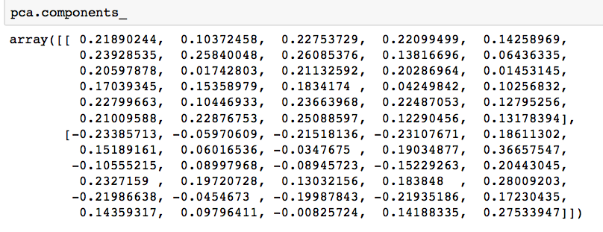

Python3

df_comp = pd.DataFrame(pca.components_, columns = cancer['feature_names'])

plt.figure(figsize =(14, 6))

*# plotting heatmap*

sns.heatmap(df_comp)

**Output:**

